Commercial Crime is a very unusual product. It has features that apply in multiple places if certain coverages are added (Inside the Premises for example.) It feels a bit like an M.C. Escher painting with staircases that seem to go nowhere and everywhere all at once.
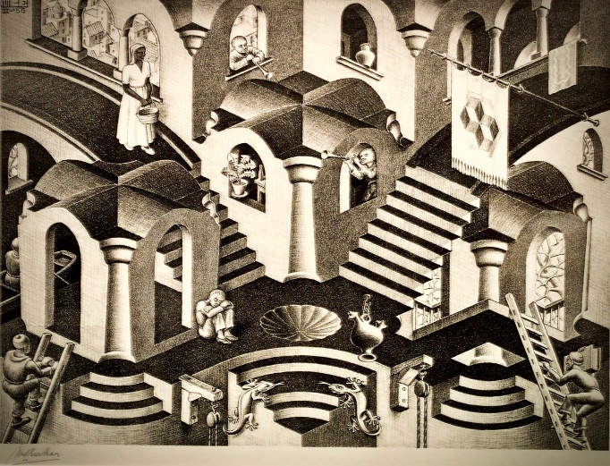
This complexity coupled with the lack of a functional SBT for Crime has caused this to be one of the more difficult products to code while also having the smallest number of available coverages.
This Photo by Unknown Author is licensed under CC BY
This product was worked last in the hopes that GuideWire would have fixed the Crime SBT. However, that didn’t happen. The UI was coded quite hastily, and only the coverages that are currently written on production Crime policies were coded in the system. (Current legacy Crime offers more coverages/options, however since we hadn’t written any policies with them, they were not included in the conversion efforts to save time.)
The policy level coverages are pretty straightforward, but the location level coverages often more closely resemble Inland Marine structure in the data. The layouts for the Crime Dec and Quote were based on how the data was being sent in the payload rather than resembling other location coverage presentations. It is likely these would be revisited if the screens change since it’s possible that the screen changes would allow the data to be organized differently on the dec/quote.
There are multiple options available for “Inside the Premises” coverages:
- Theft of Money and Securities
- Robbery or Safe Burglary of Other Property
- Theft of Other Property
- Robbery of A Watchperson or Burglary of Other Property
- Robbery of a Custodian or Safe Burglary of Money and Securities
The policyholder can choose just 1 of these or all of them. The deductible chosen for each of these is then applied to every coverage that also includes that item. So for instance, if the deductible for “Theft of Money or Securities” is $1,000. We would show that amount on other coverages that had included “Theft of Money or Securities”. (This is not well represented in the mockups, unfortunately.) It is important to note that just because “Theft of Money or Securities” is available for multiple coverages, the policy does NOT automatically apply it to the coverage. It must be chosen in the UI. (See examples next page.) Note that Outside the Premises could work similarly if we had it in legacy Crime policies.
There are 2 specific coverages that were coded so differently that they have a separate table “Other Location Coverages”: (See examples next page)
- Decreased Limit of Insurance while Premises not Open for Business
- Reduce Limit of Insurance for Designated Premises
Each of these coverages can only be applied to 1 location at a time due to how the UI was designed.
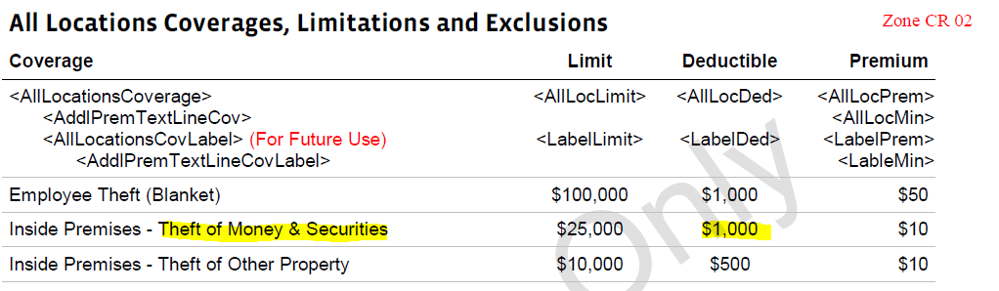
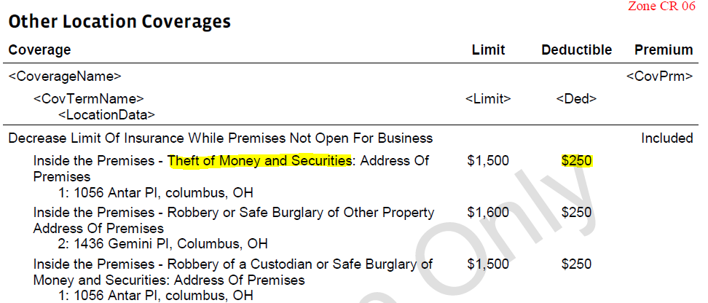
*Note that the $1,000 deductible in the policy level coverages table should be the same in the “Other Coverages” table (and not $250.) This was a miss in the mockup.

